How To Clean Your Room
Cleaning your room is actually not that hard ,if you think about it. This is my way of cleaning my room:

First of all, you don’t really need anything special, just maybe a trash bag if your room has a lot of trash on the ground. Also if your one of those people who get grossed out, well get used to it or, get some gloves because this article is for people who can deal with it.
Step #1

If you’re a person like me, I suggest you listen to some music to get you going so you won’t get bored while your cleaning. Also, just so you know, when I say cleaning., I just mean picking up. This is not a major cleaning this is very basic cleaning so your room looks nice and todally trashed.
Step #2
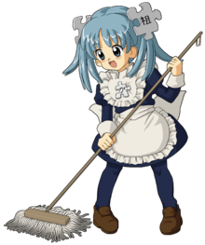
You can sort witch categories you clean up. For an Example: pick up all of the cloths first, pick up the stuffed animals first, ect.
Or, maybe you can just go in their and just start picking up things.
Step #3
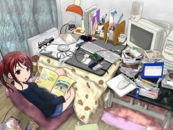
Cleaning you room doesn’t mean stuffing things in your closet or, under your bed. Instead you clean out the thing out from under your bed and out from your closet. Also, put things in the right places. If you don’t have enough space, try to organize your stuff into boxes and label the boxes into categories. Otherwise, you can just throw away unwanted stuff, or sell them, even donating them. There are many other ways to organize but, this is how to clean your room, not organize.
Step #4

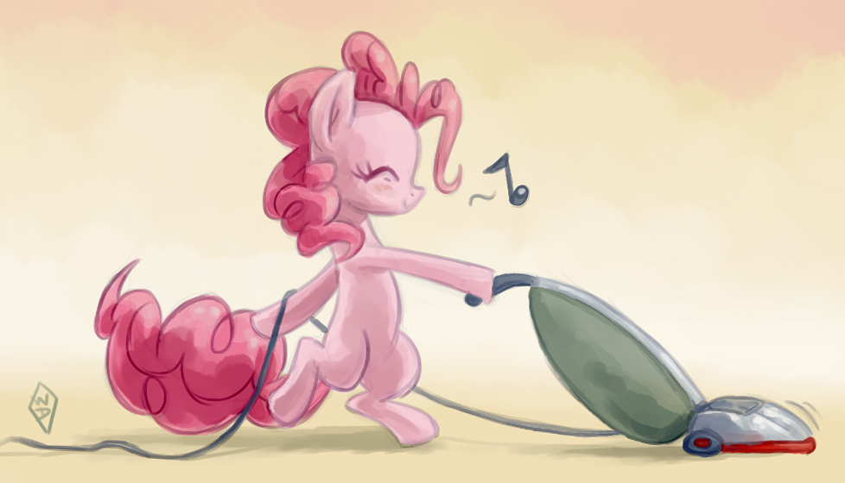When your finished with picking everything up, you can vacuum after words to make you room look nicer. You can also use the hose to vacuum the corners and the border of the room. Make sure you have everything picked up and things that are too big for your vacuum picked up! Also, you can spray air freshener so your room smells good too!
Step #5

Enjoy your clean room ,and keep it nice and neat! Thanks for reading my article and I hope it was helpful for you!
Ahh , don’t you like a nice clean room?

